SOME OF THE ERRORS IN ECLIPS (MAVEN PROJECT) AND SOLUTIONS FOR THAT ERRORS

BY M.B.A.SHANJITH JOY

|  |  |  |
| --- | --- | --- |
| S.NO | CONTEXT | PAGE.NO |
| 1 | 404 ERROR | 2 |
| 2 | TOMCAT SERVER FAILED TO START ERROR | 5 |
| 3 | TOMCAT SERVER PORT 8080 IS ALREADY IN USE ERROR | 8 |
| 4 | JASPER EXCEPTION ERROR | 10 |
| 5 | 500 ERROR WITH REQUEST PROCESSING FAILED | 10 |
| 6 | ERROR IN POM.XML | 11 |
| 7 | ERROR IN DISPACHER-SEVERLET | 14 |
| 8 | CONTAXT LISTENER ERROR | 14 |
| 9 | BEAN CREATION FAILED ERROR | 14 |
| 10 | XML DOCUMENT ERROR | 15 |

1.404 ERROR

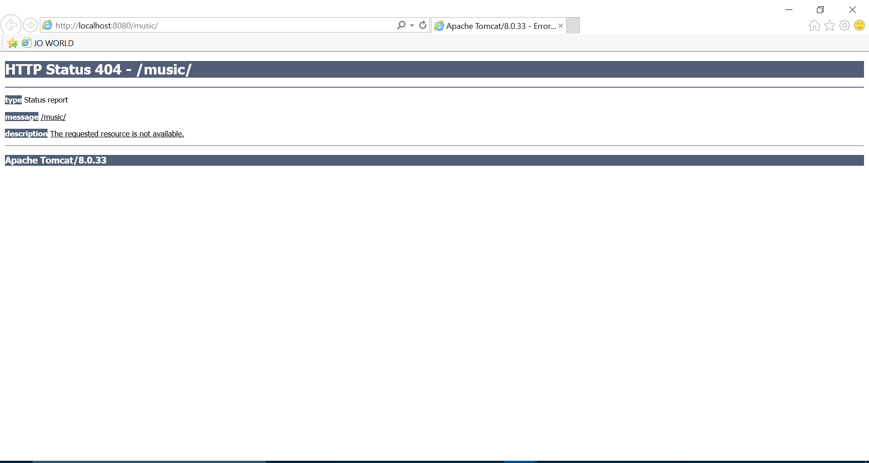

RESONS:

* This is also known as page not found error.
* This error may be created due to improper or incorrect mapping in controller.
* This may also arise if you have failed to add dependency to your project.
* This may also arise due to improper internet connection.

SOLUTIONS:

* Right click on your project and go to properties.

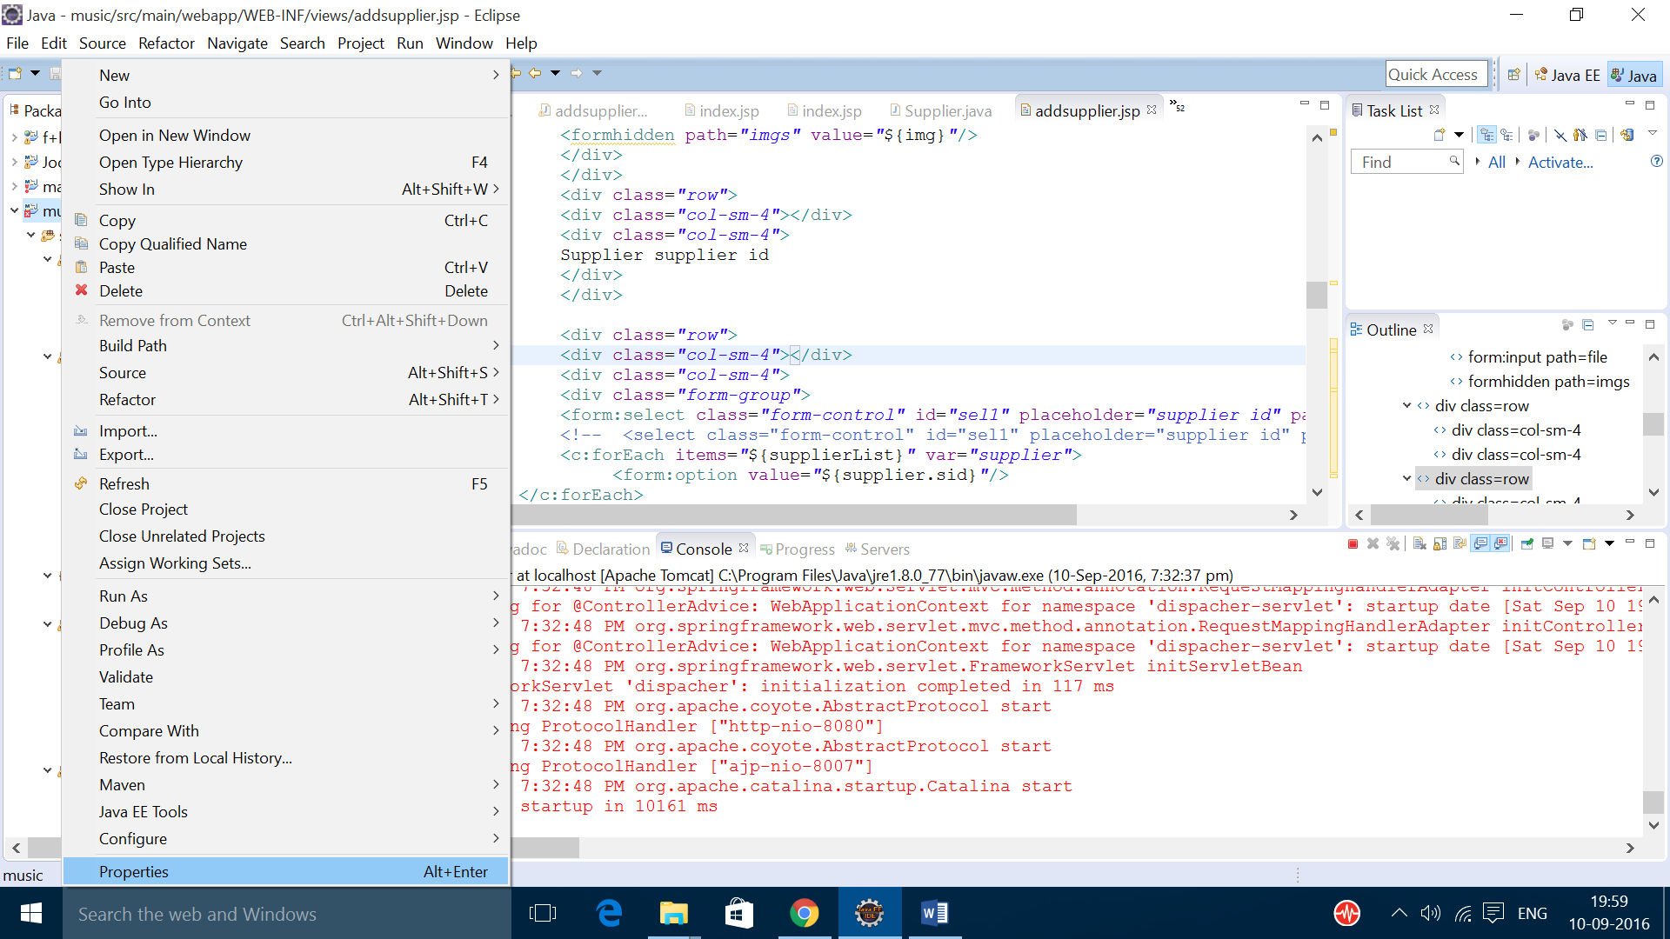

* Check the maven dependency if it is blank click and check on it

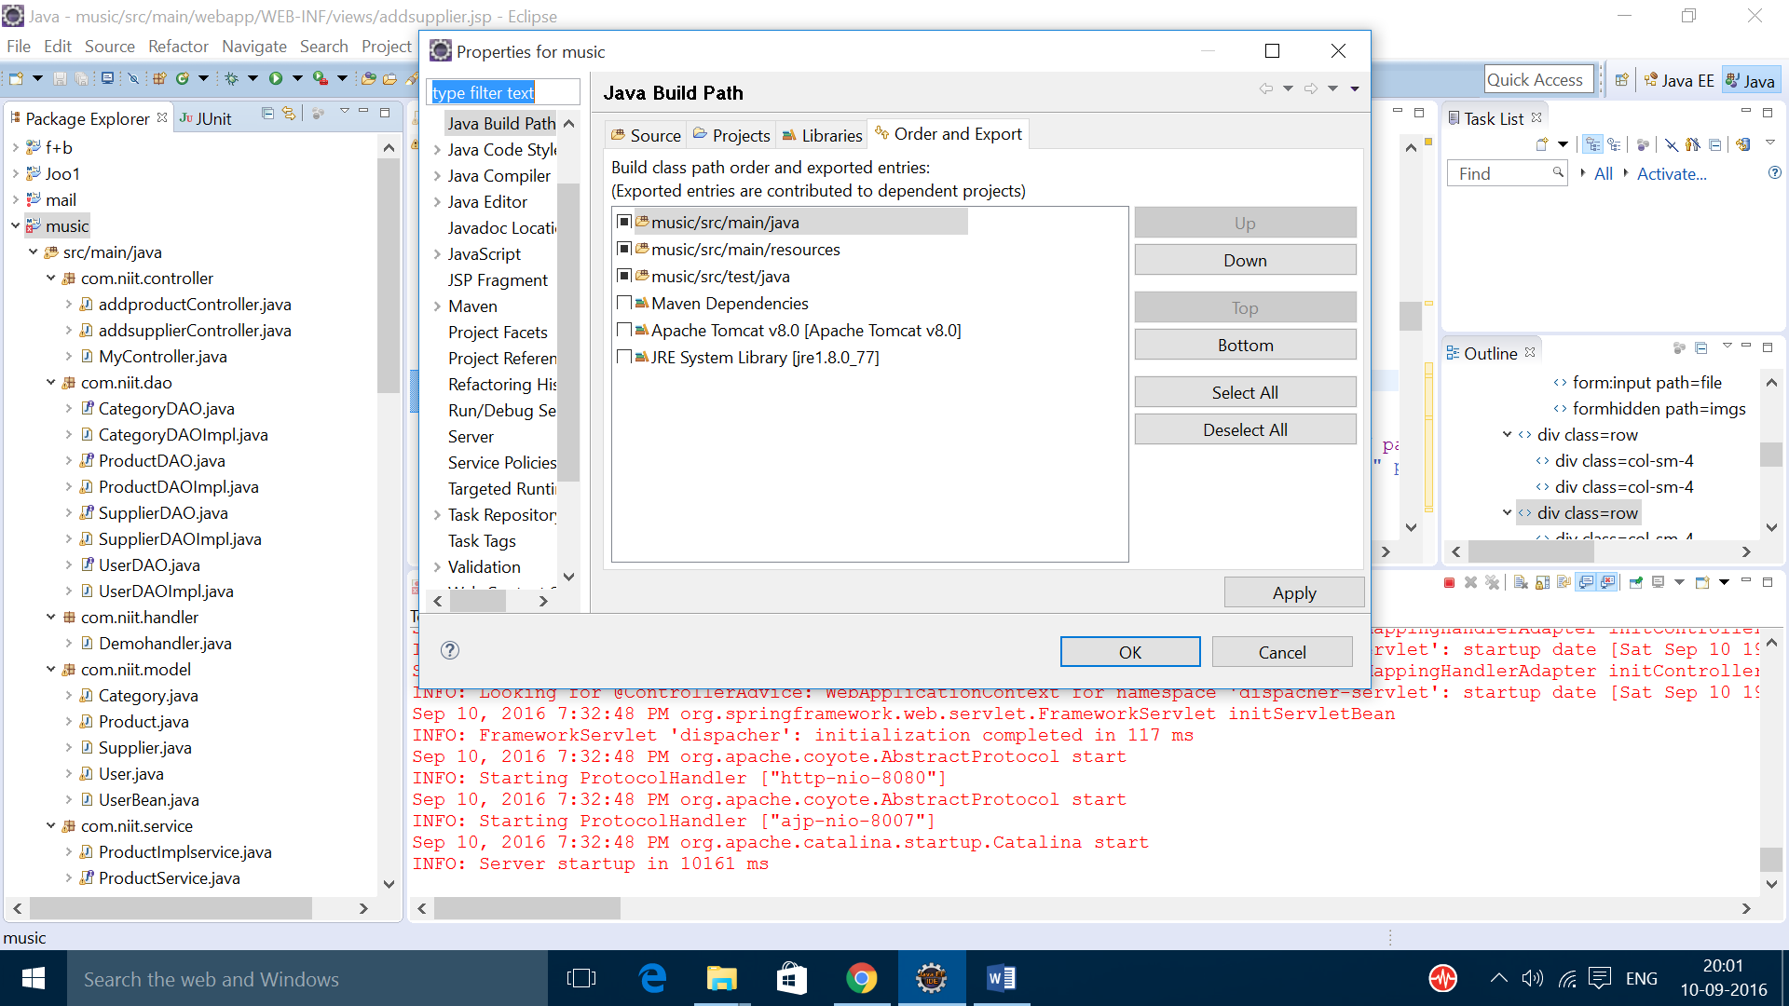

* After adding the dependency it should look like this

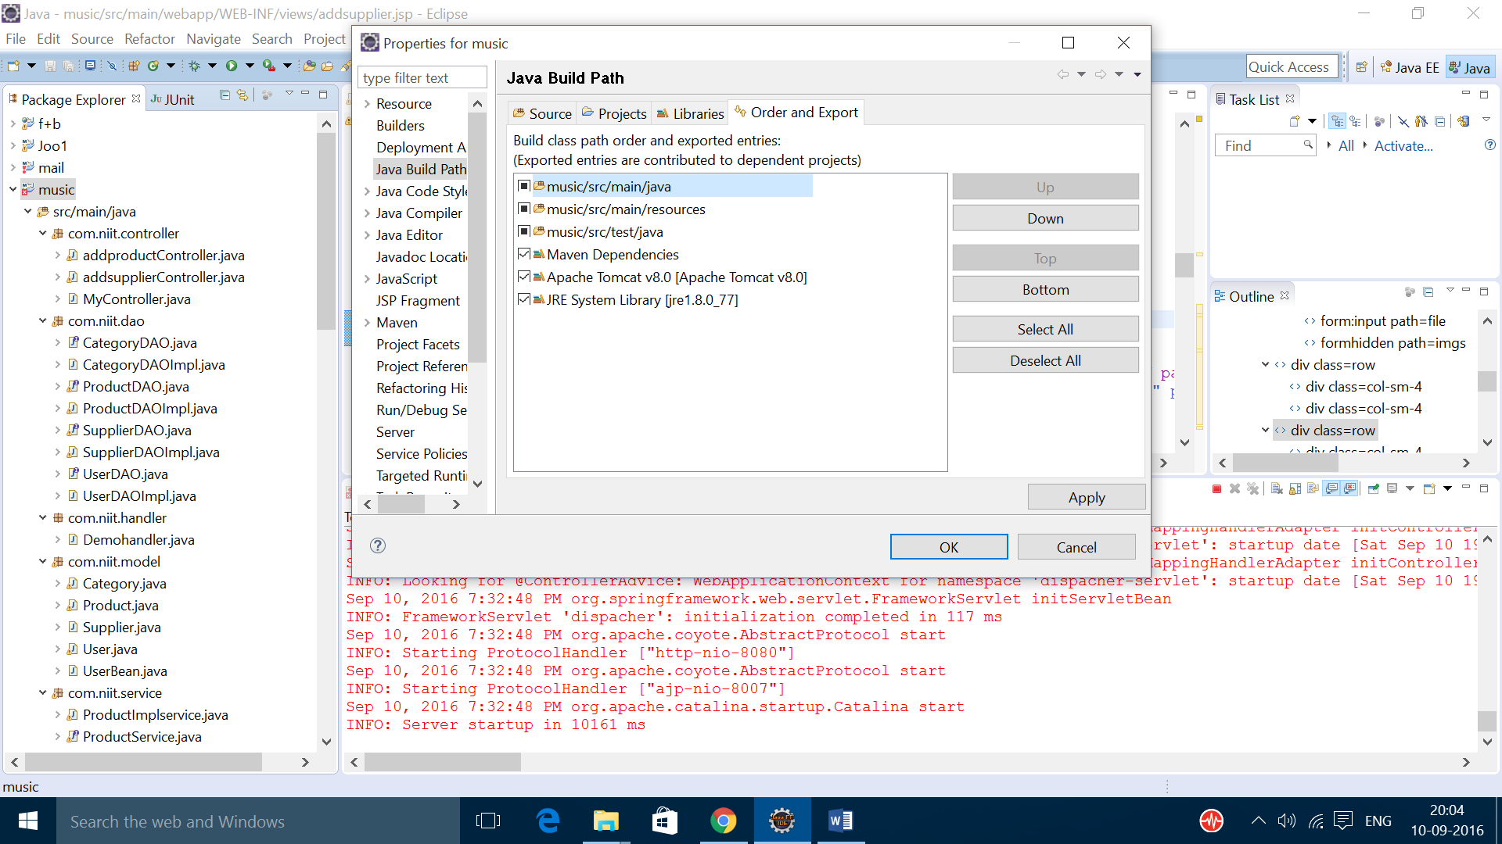

* Then click apply
* Then check weather maven dependency is added or not if not add maven dependency

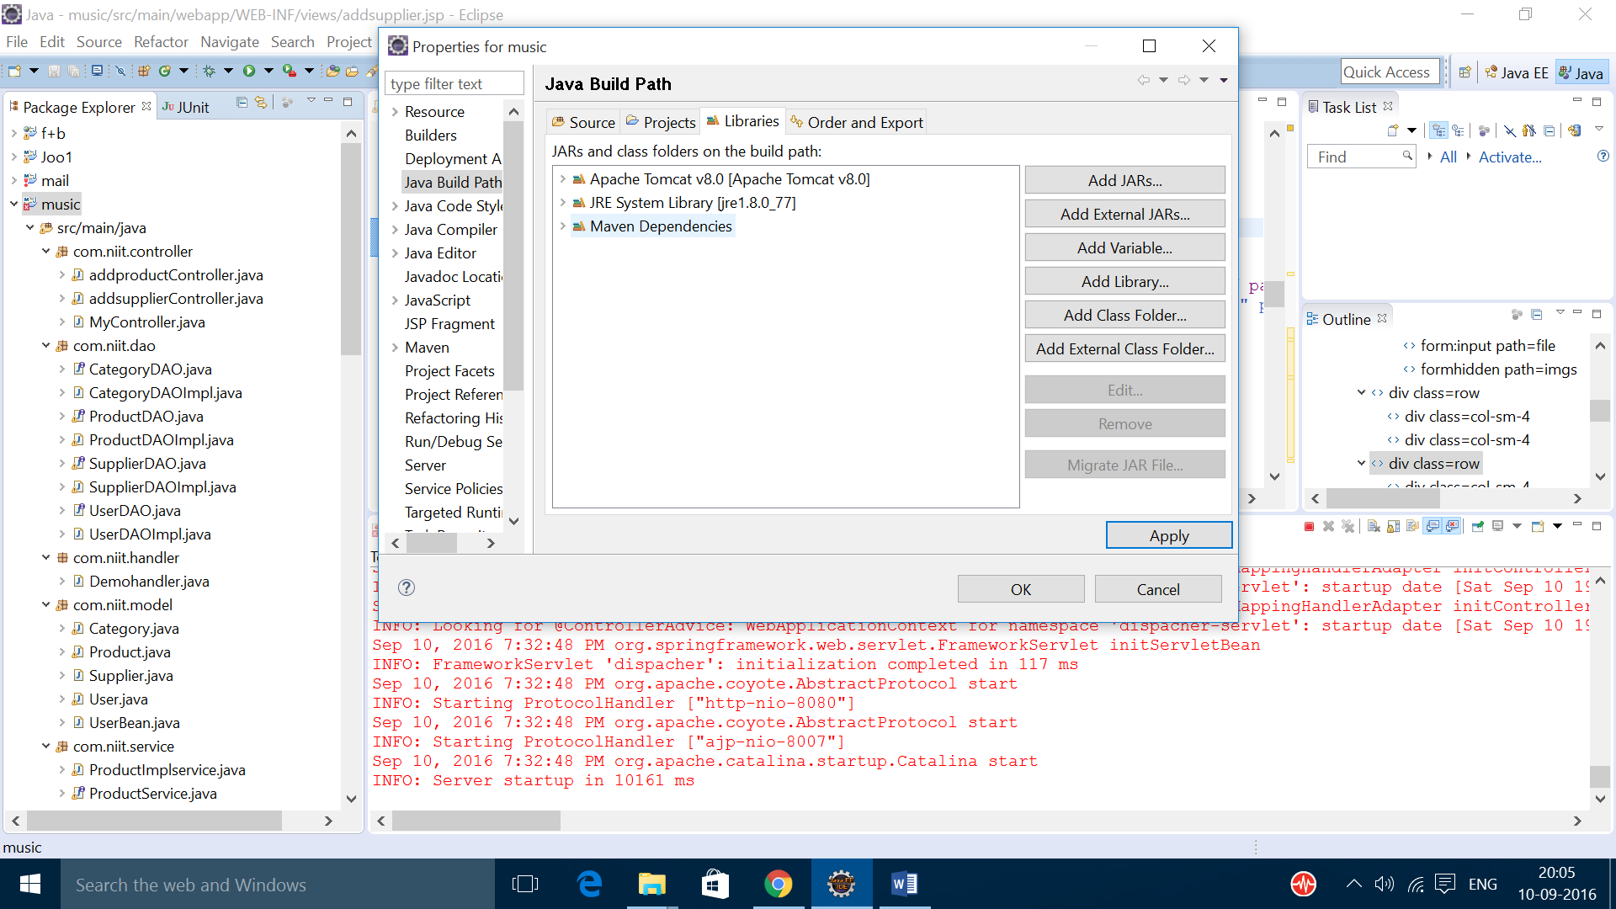

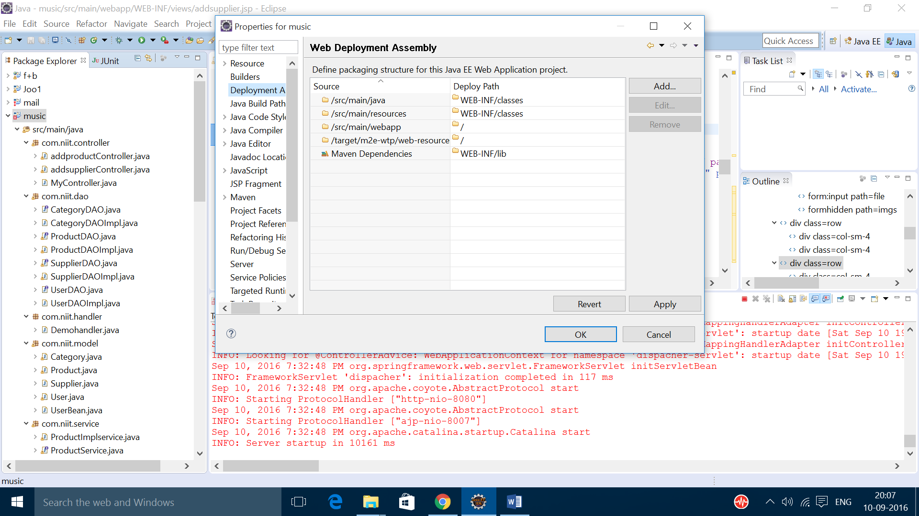

* After checking everything try to run the project.
* If you got 404 again try to update your project and follow the above steps
* Still it fails to work check the problems in console and controller.

2. TOMCAT SERVER FAILED TO START ERROR

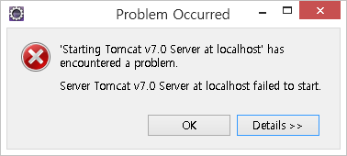

REASONS:

* This problem may arise due to overloading of the Tomcat server.
* This is also due to unwanted data’s in the server.

SOLUTIONS:

* Try to clean the server
* Right click on the server

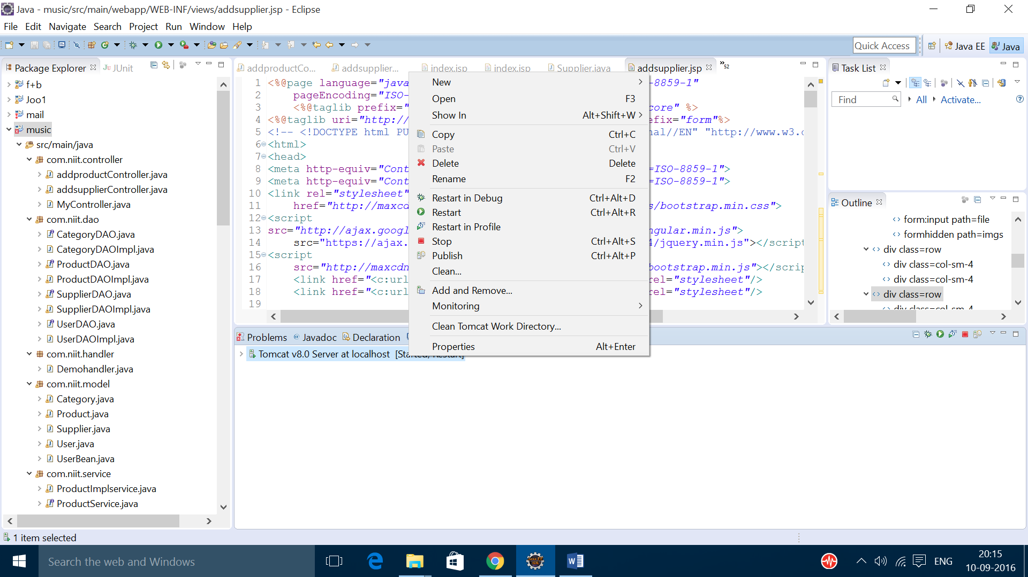

* Click on clean

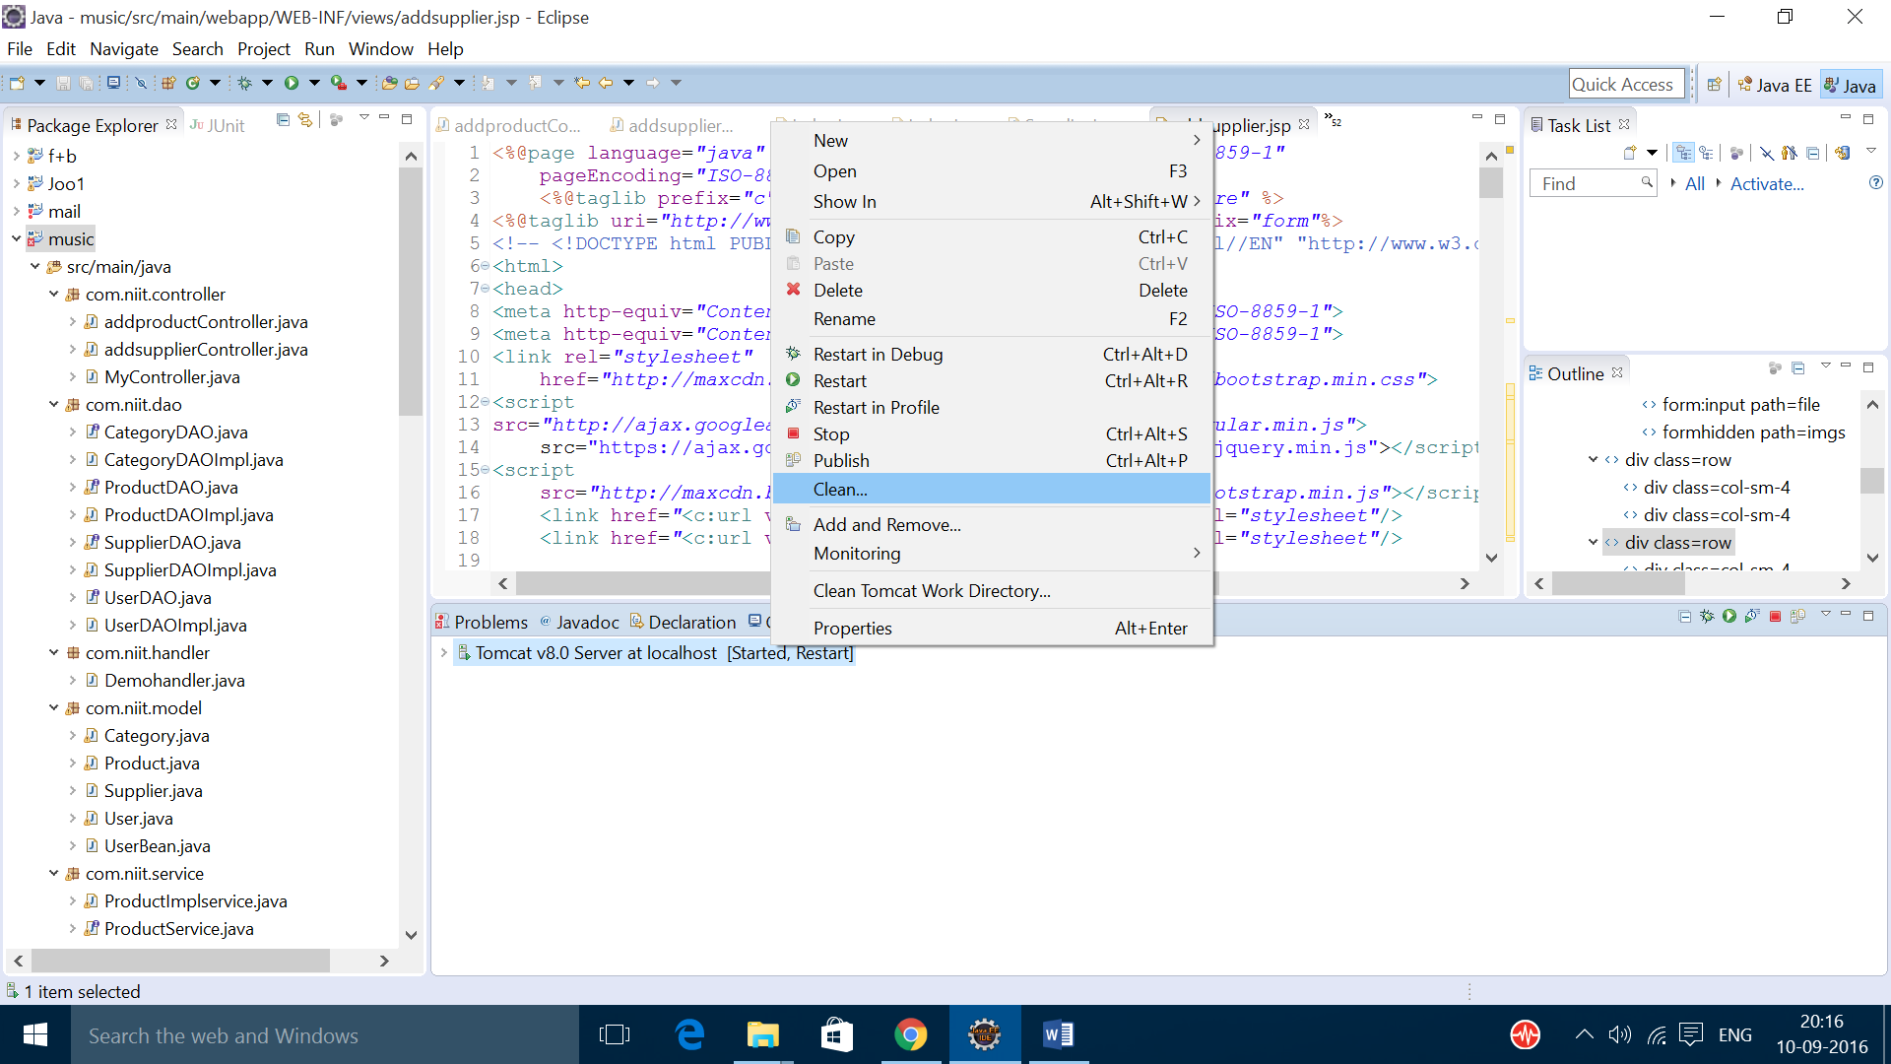

* After completing cleaning process.

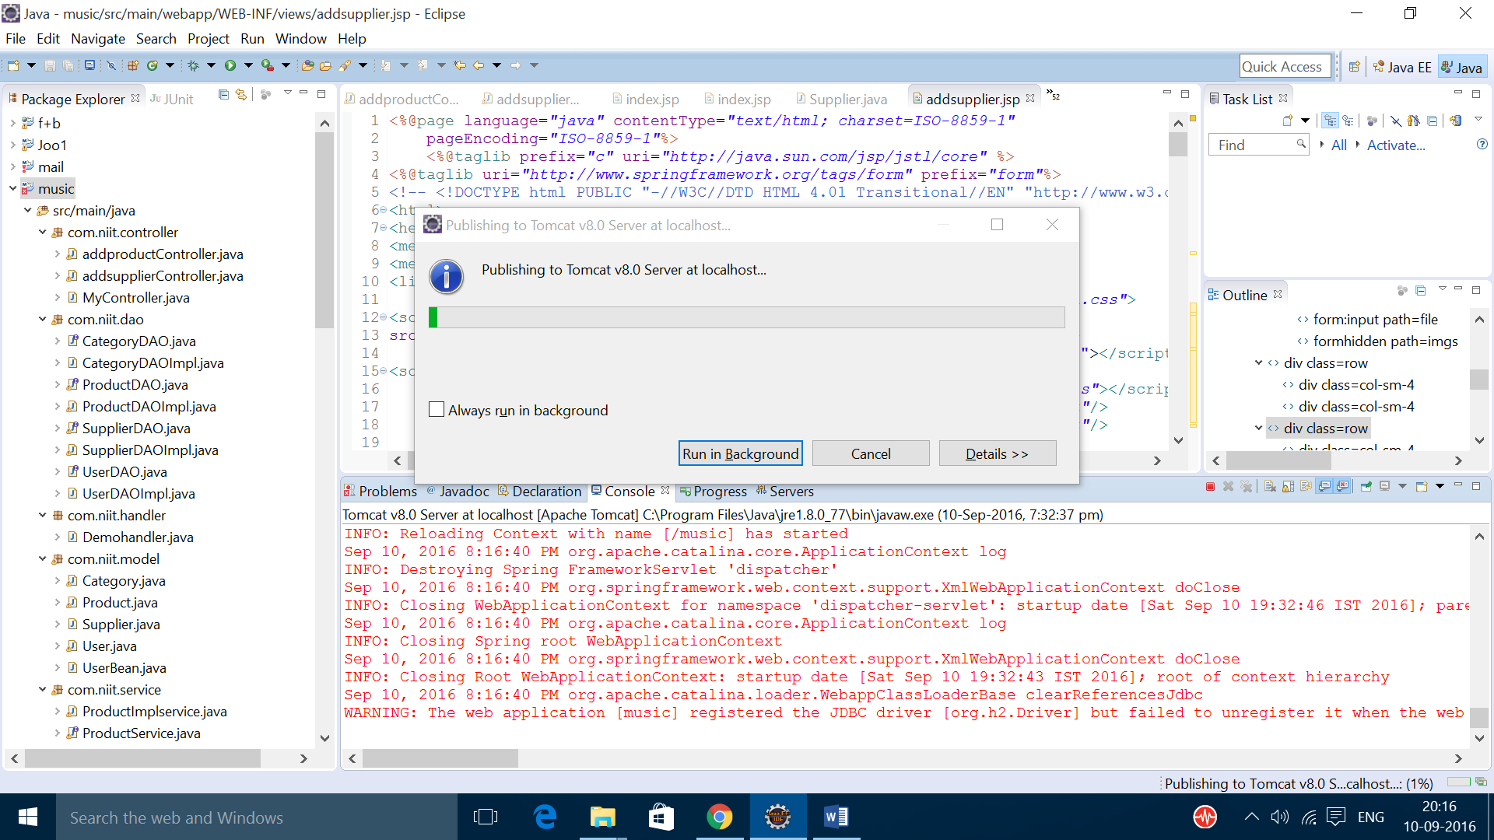

* Clean the work directory also

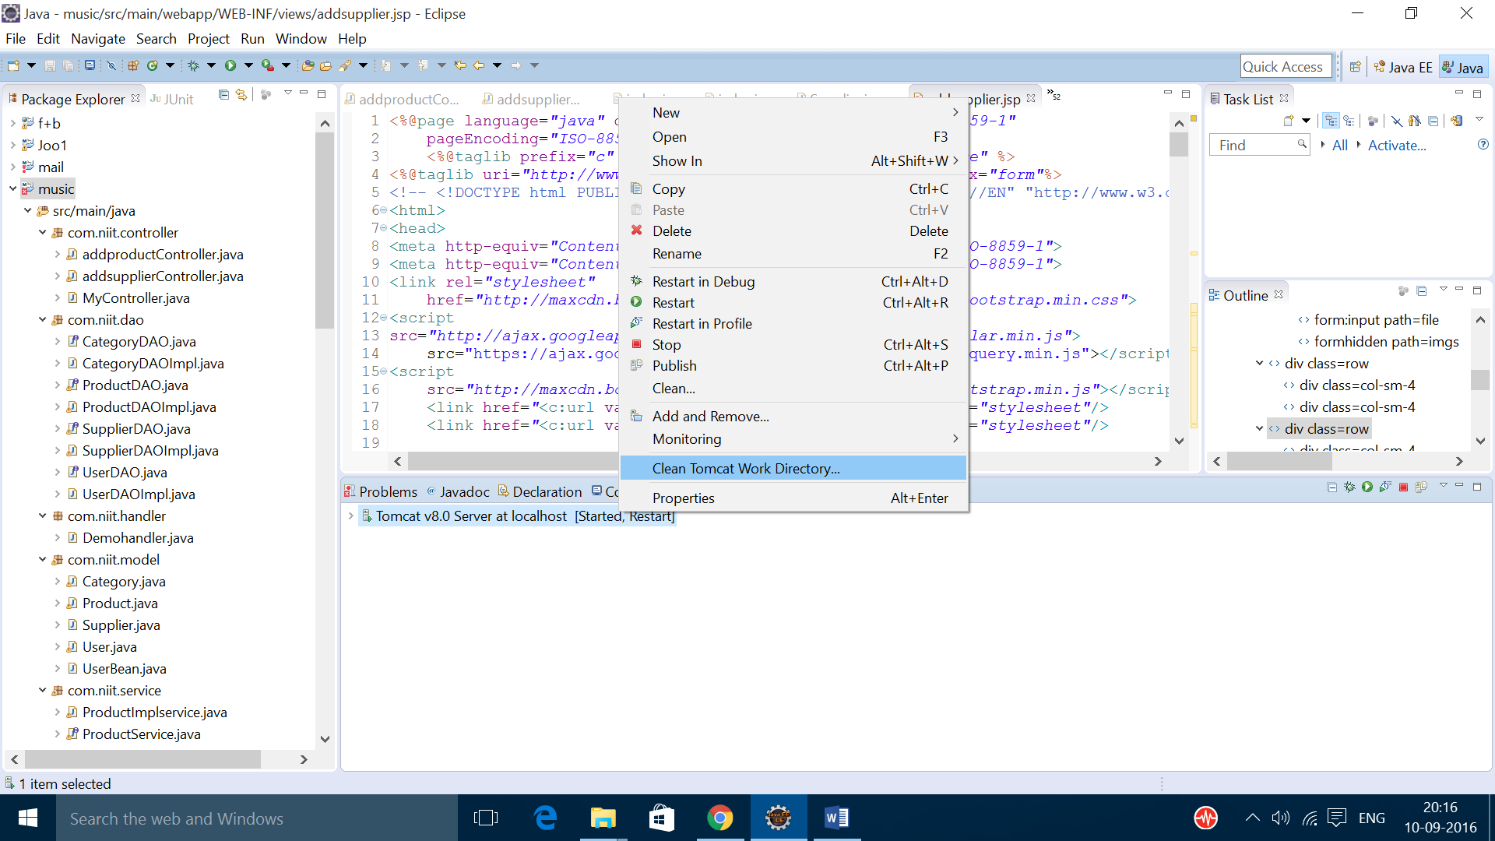

* Then try to start the server by right clicking on it.

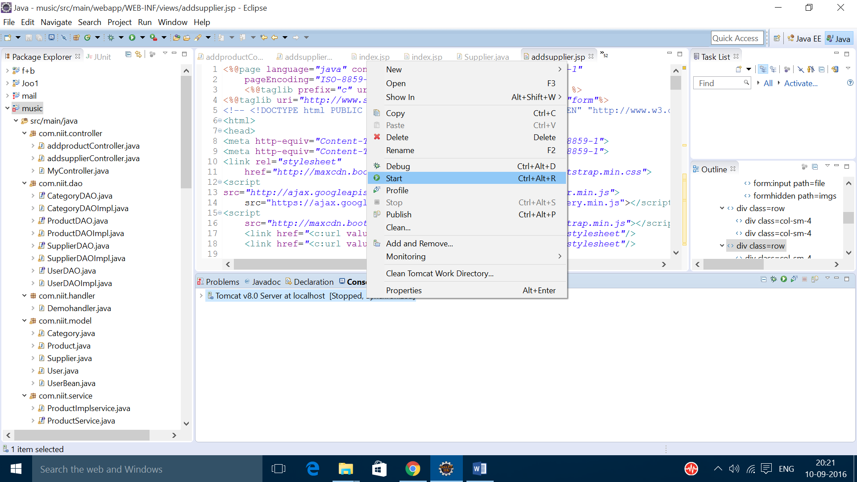

3. TOMCAT SERVER PORT 8080 IS ALREADY IN USE ERROR

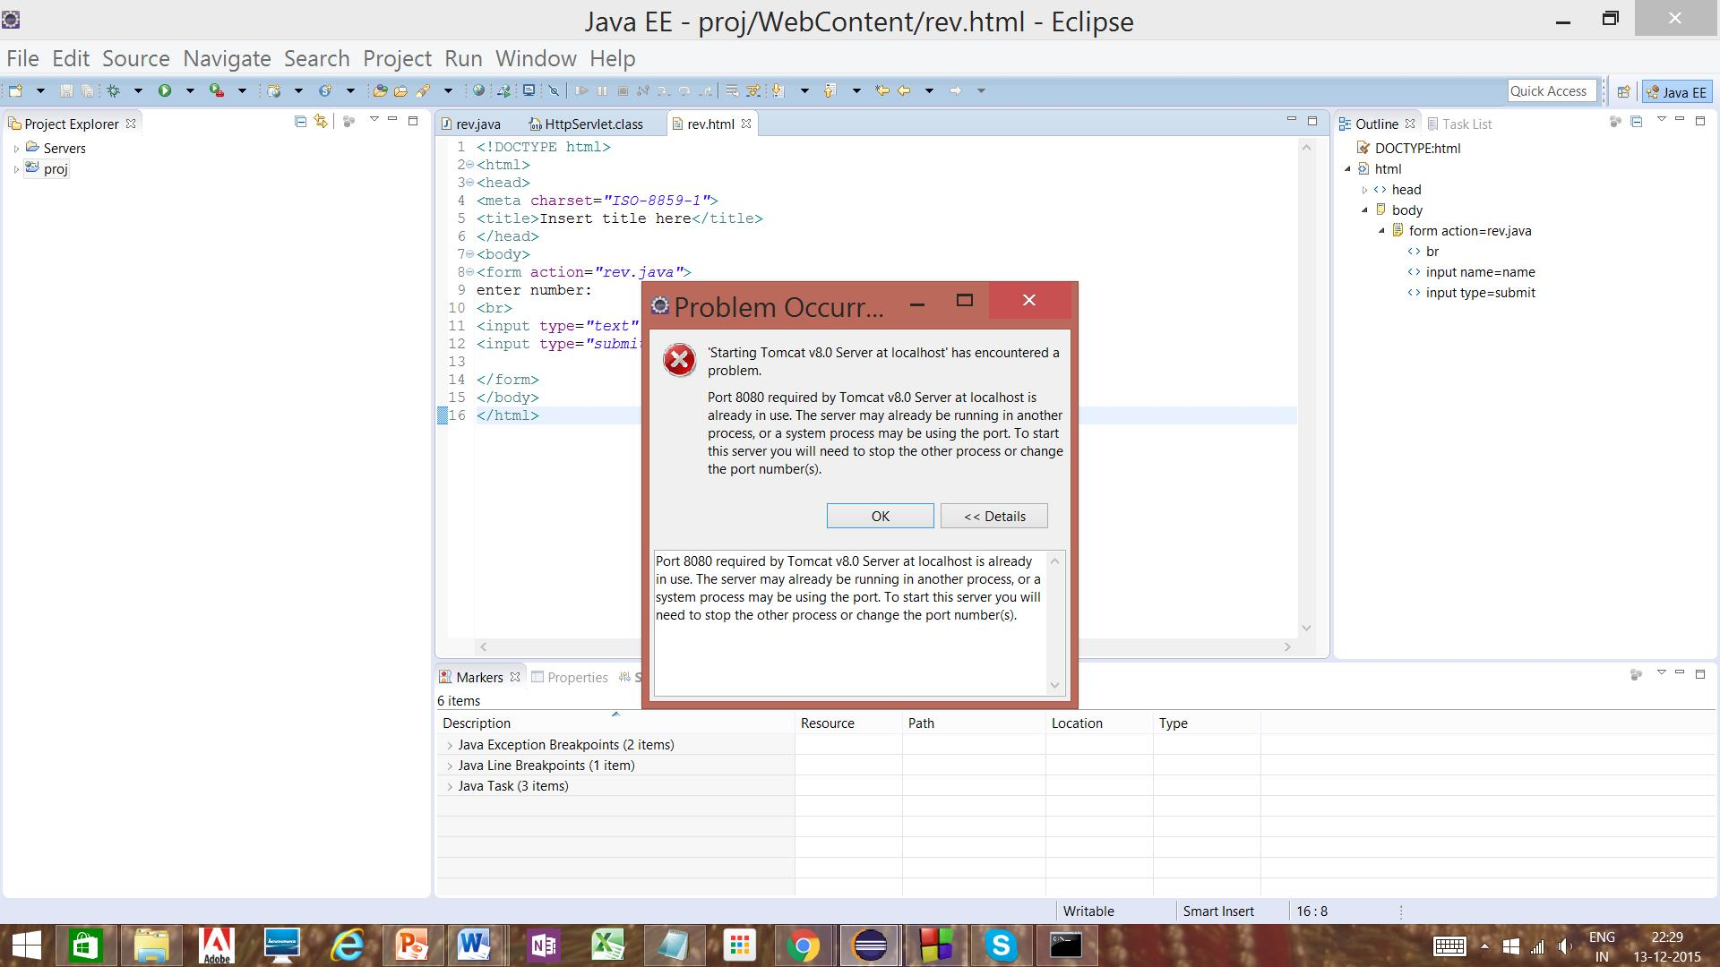

SOLUTIONS:

* This error can be cleared by changing the port numbers.
* The steps to change port numbers are as follows
* Right click on the server and click open

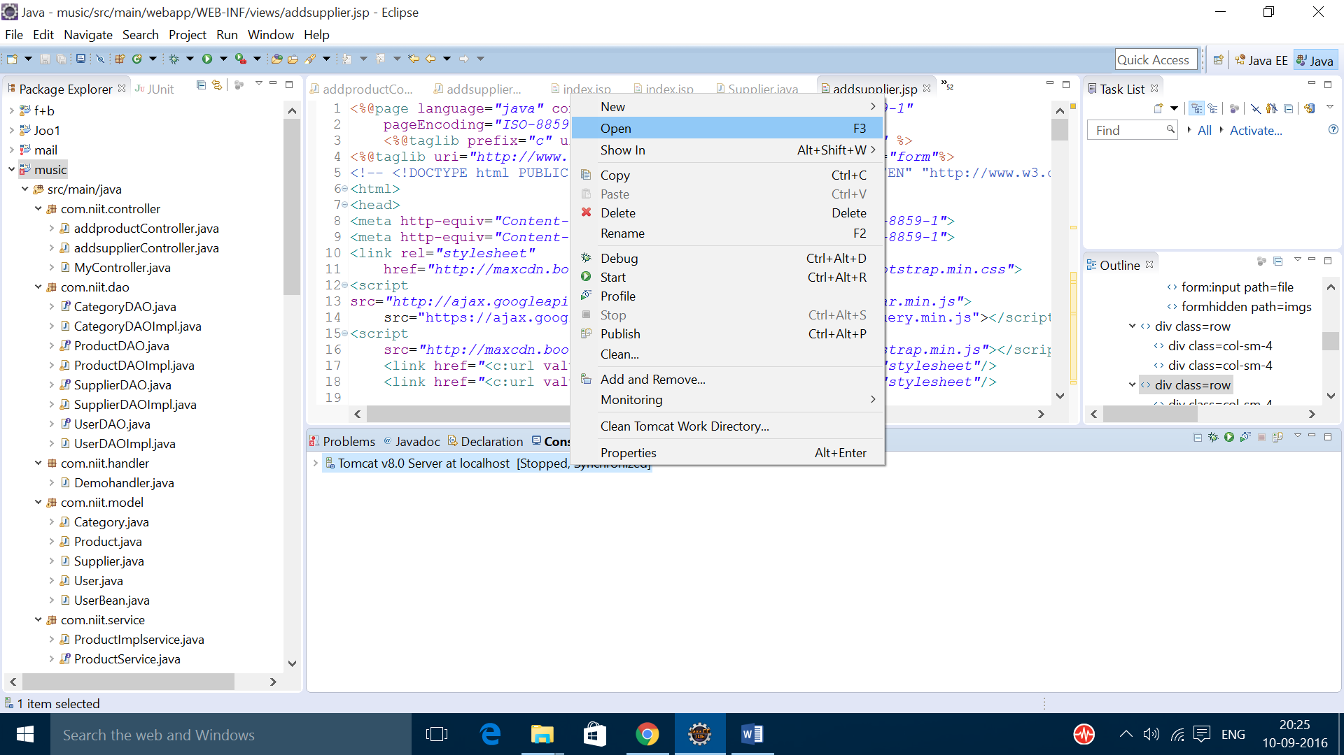

* You can see the port numbers if u scroll right.

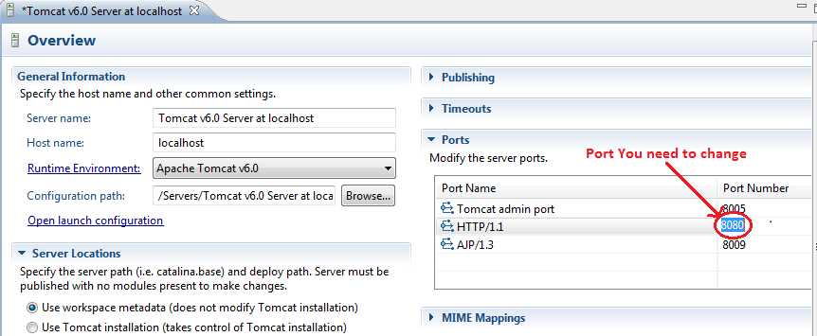

* Change the port numbers and try to start the server.

NOTE: DON’T USE PORT NUMBER 8082 THIS PORT NUMBER BELONGS TO H2 DATABASE IF YOU USE THIS PORT NUMBER YOU WILL GET PROBLEMS WHILE OPENING THE H2 DATABASE

4. JASPER EXCEPTION ERROR

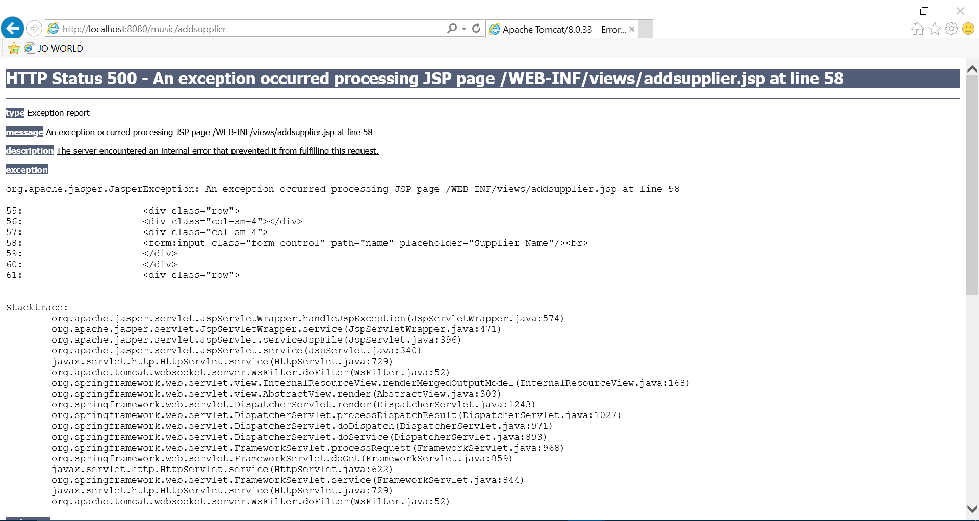

REASON:

* This may be created while you are trying to add data’s of product in to database.
* Main reason for this error is mismatch in the field names in jsp file and model
* It is also an type of 500 error
* 500 error means mapping not found, but the reason for jasper exception is mismatch in the field names in jsp file and model

SOLUTION:

* Try to check the field names in the jsp file and the model you have created

5.500 ERROR WITH REQUEST PROCESSING FAILED

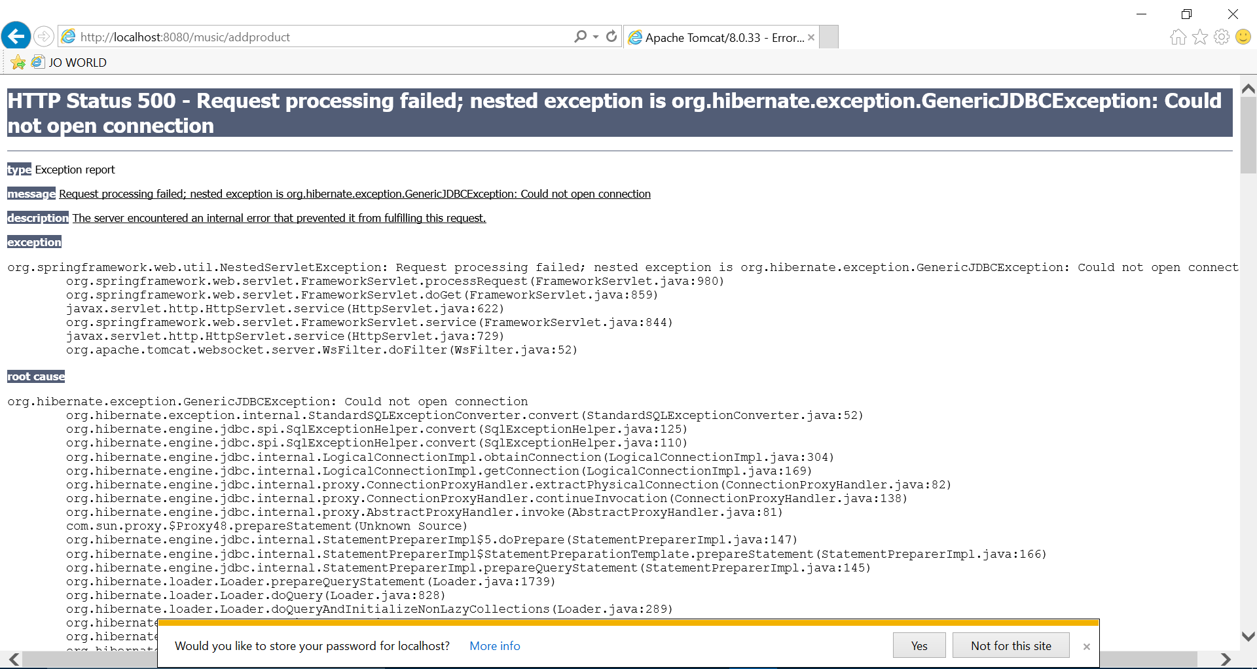

REASON:

* This error arise when you try to run the project without opening the database.
* Some may get this error while running the project itself or it may also arise while you enter into the page where you add the project details

SOLUTION:

* Try to run your project with database kept open.

6. ERROR IN POM.XML

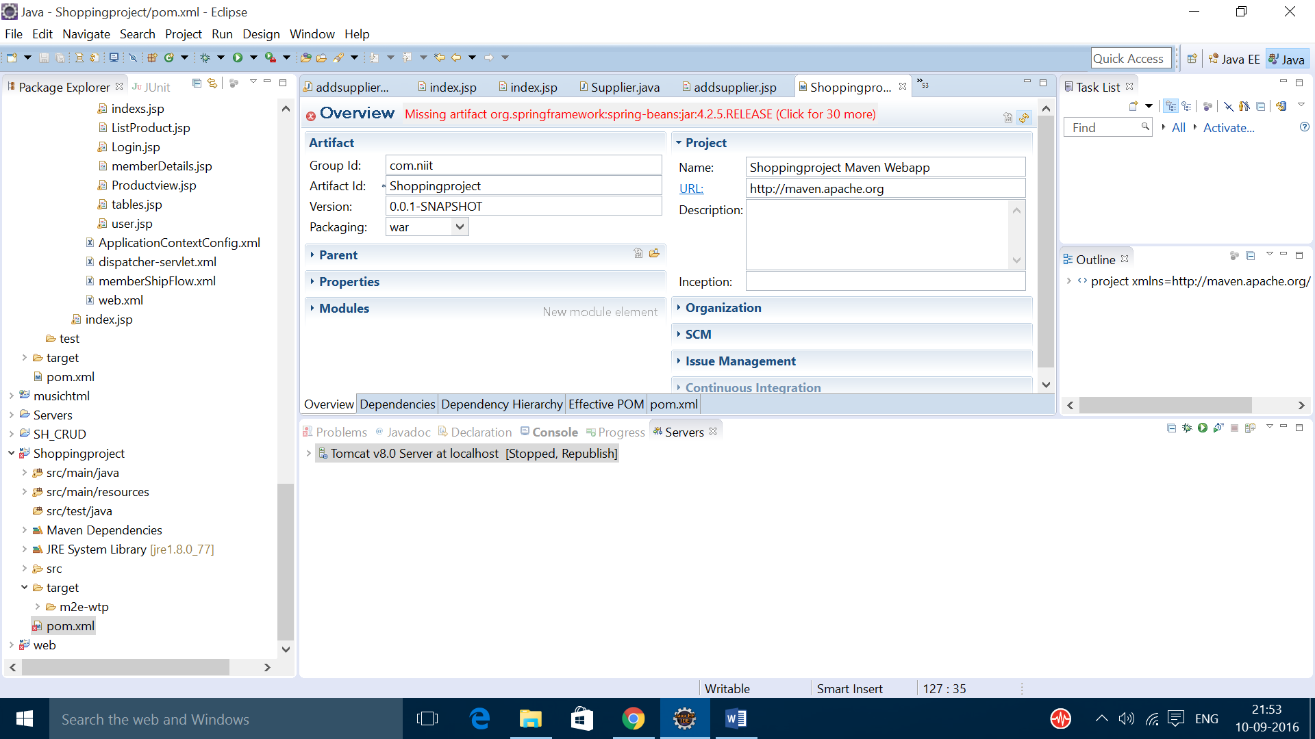

REASON:

* This is due to missing of dependency installation.

SOLUTION:

* Add the required dependency in the pom.xml
* Right click on the project

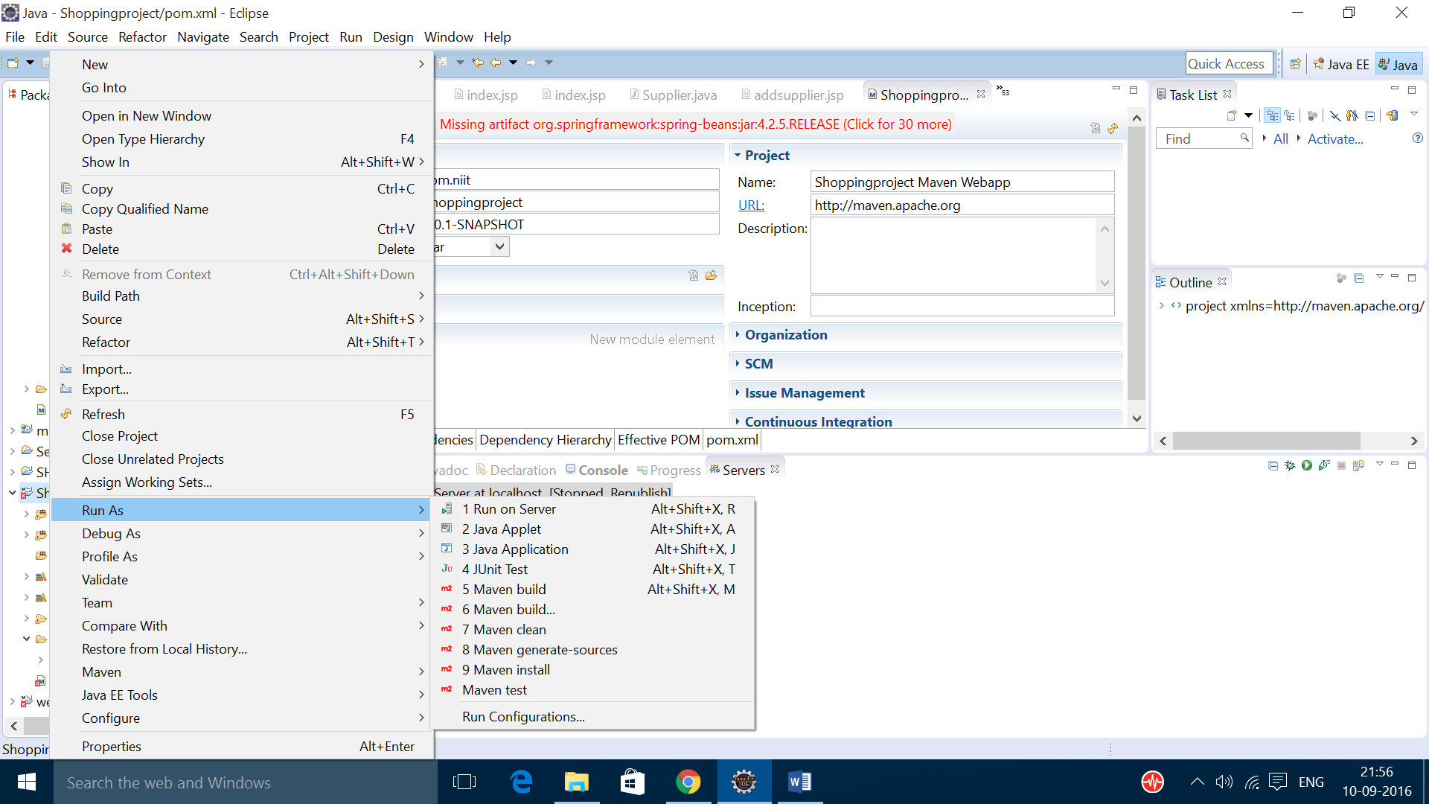

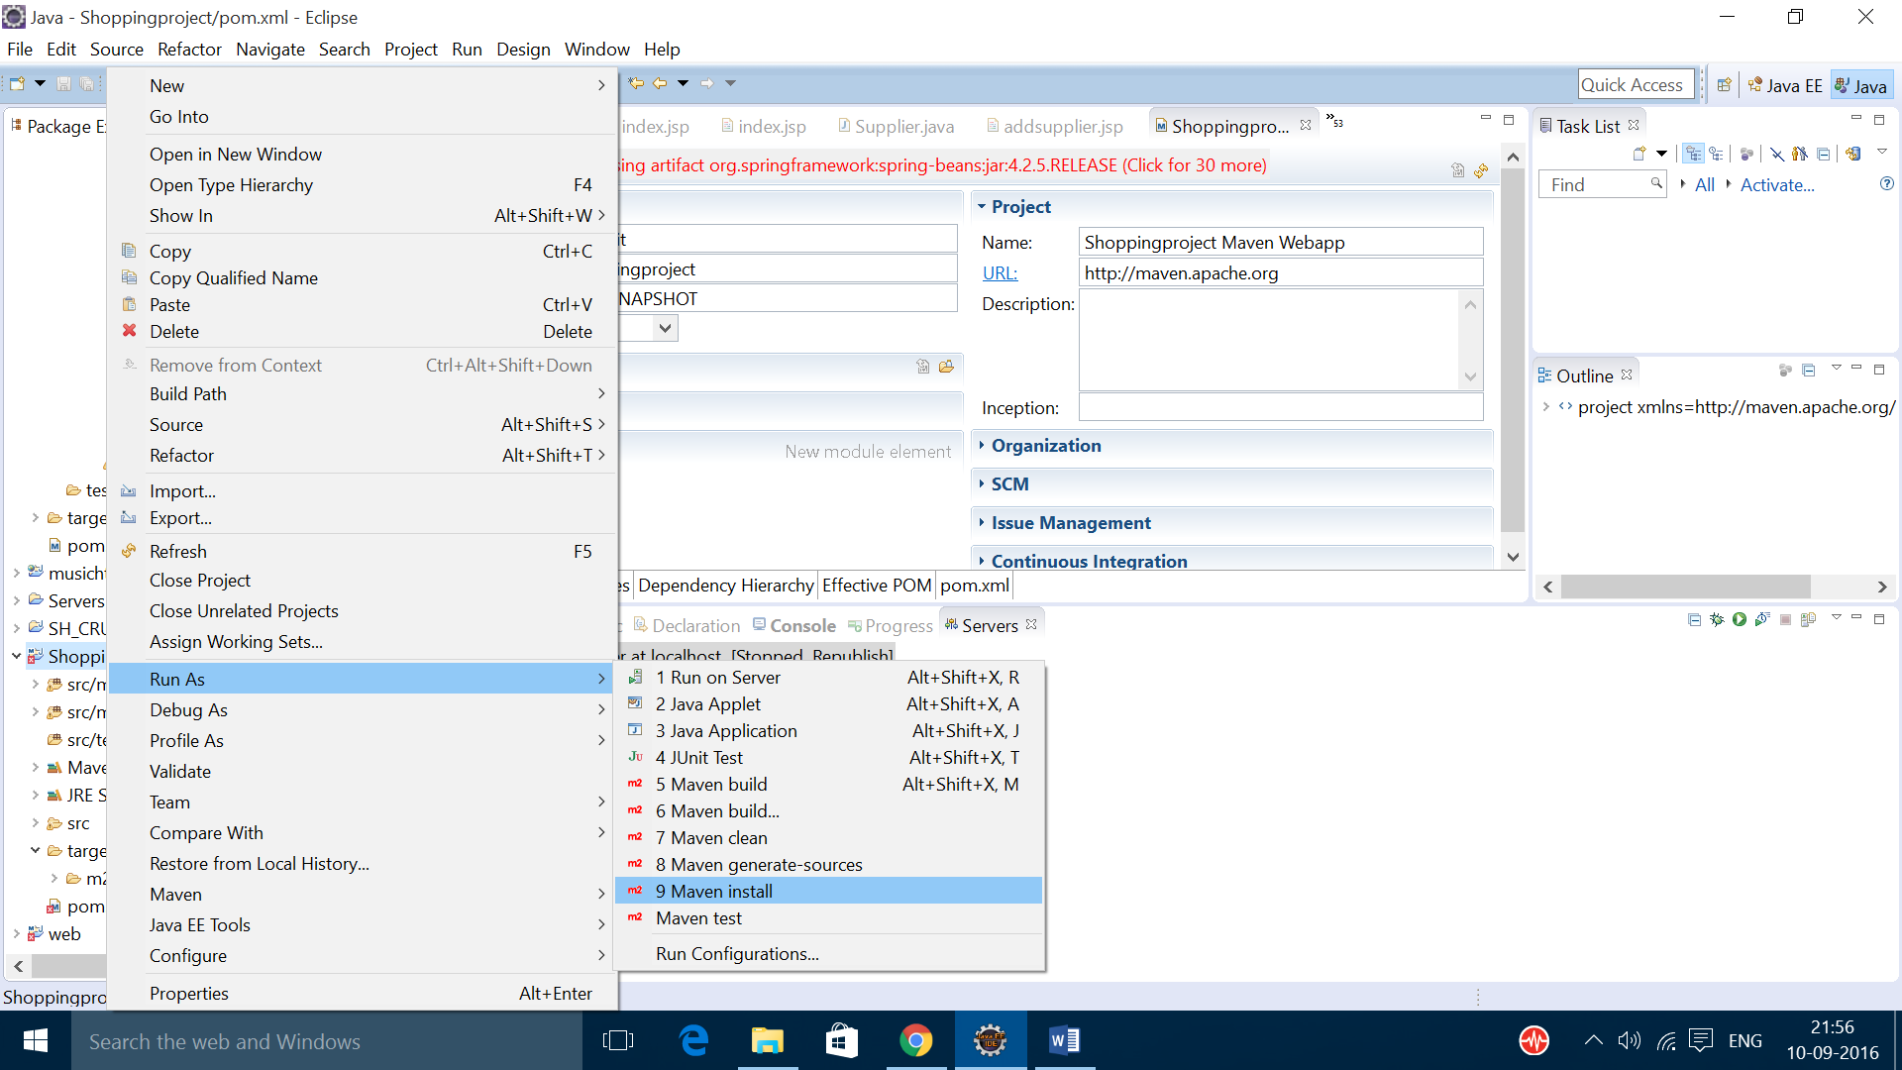

* Click on maven install
* If you get this build failure check the internet connection and try again

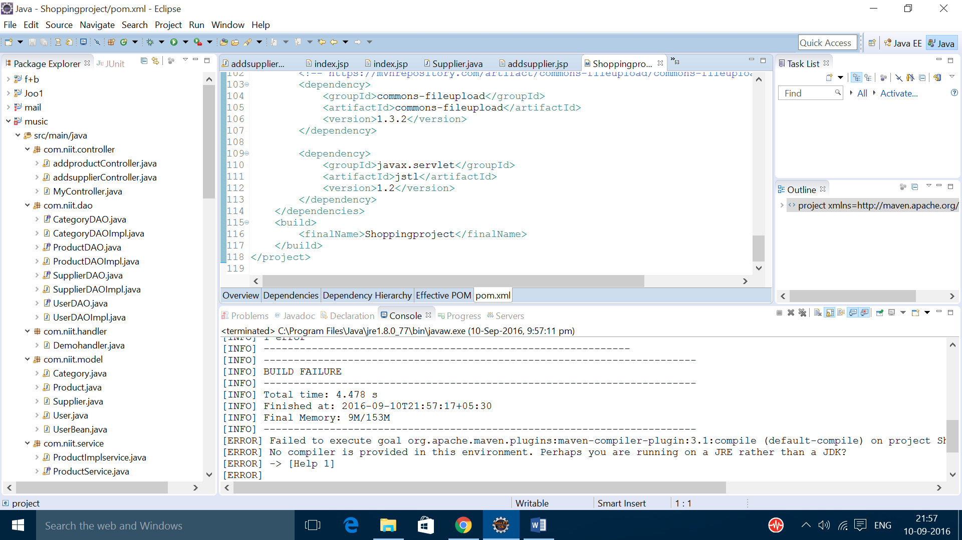

* At last you should get build success message

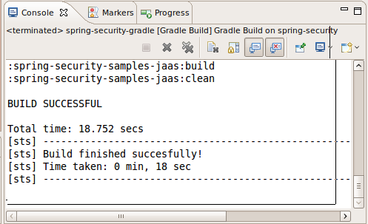

7. ERROR IN DISPACHER-SEVERLET

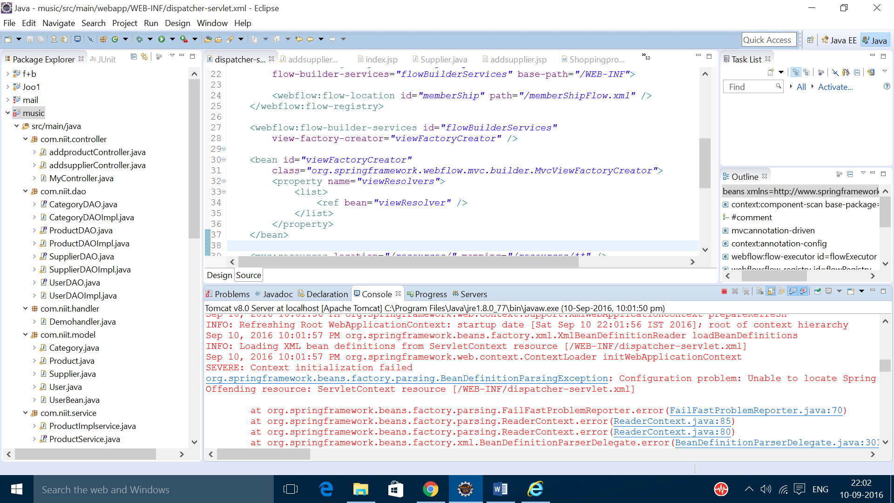

REASON:

* It is due to configuration problem in the .xml file.

SOLUTION:

* Check the coding in the .xml files.

8. CONTAXT LISTENER ERROR

REASON:

* Unknown

SOLUTION:

* Close the eclipse and restart the eclipse.

9. BEAN CREATION FAILED ERROR

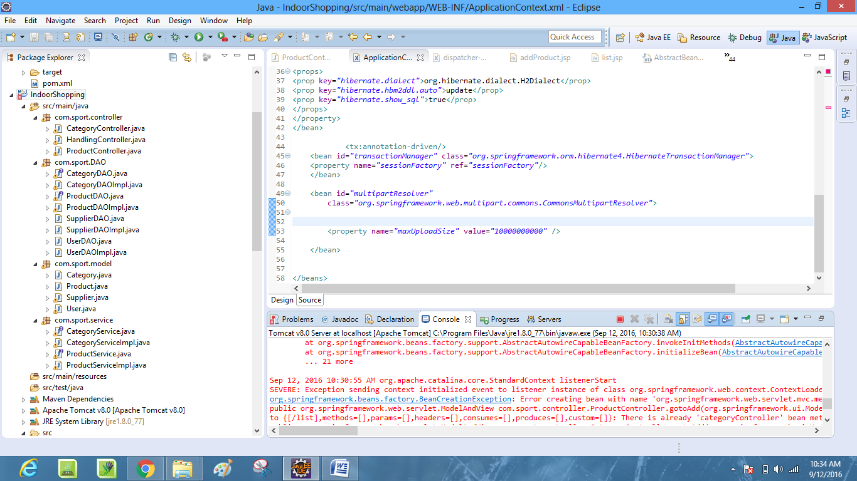

REASON:

* Unknown

SOLUTION:

* Try to update the project and run the project.
* The add the dependency and the jar files and try to run the project.

10.XML FILE ERROR

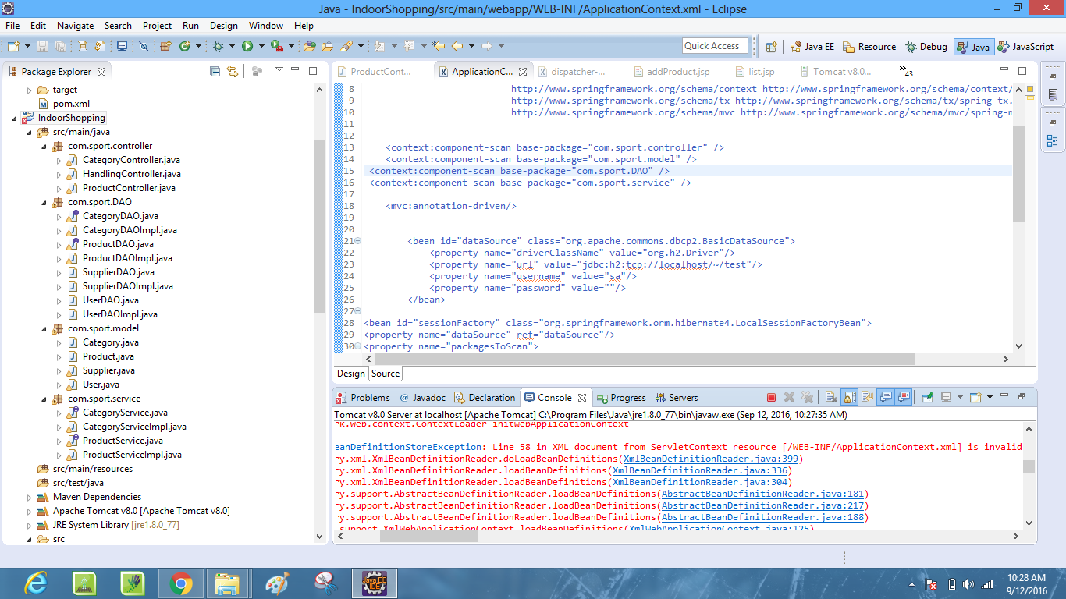

REASON:

* This is due to the error in the xml files it may be in the dispatcher , web, or application context xml file
* The advantage of this error is it shows the specific line in which the error is created

SOLUTION:

* Try to find the error in the xml document and try to solve it.